# Module 7 Assignment 2 GitHub link:

# <https://github.com/xeno1211/M7A2>

# Screenshots:

API GET

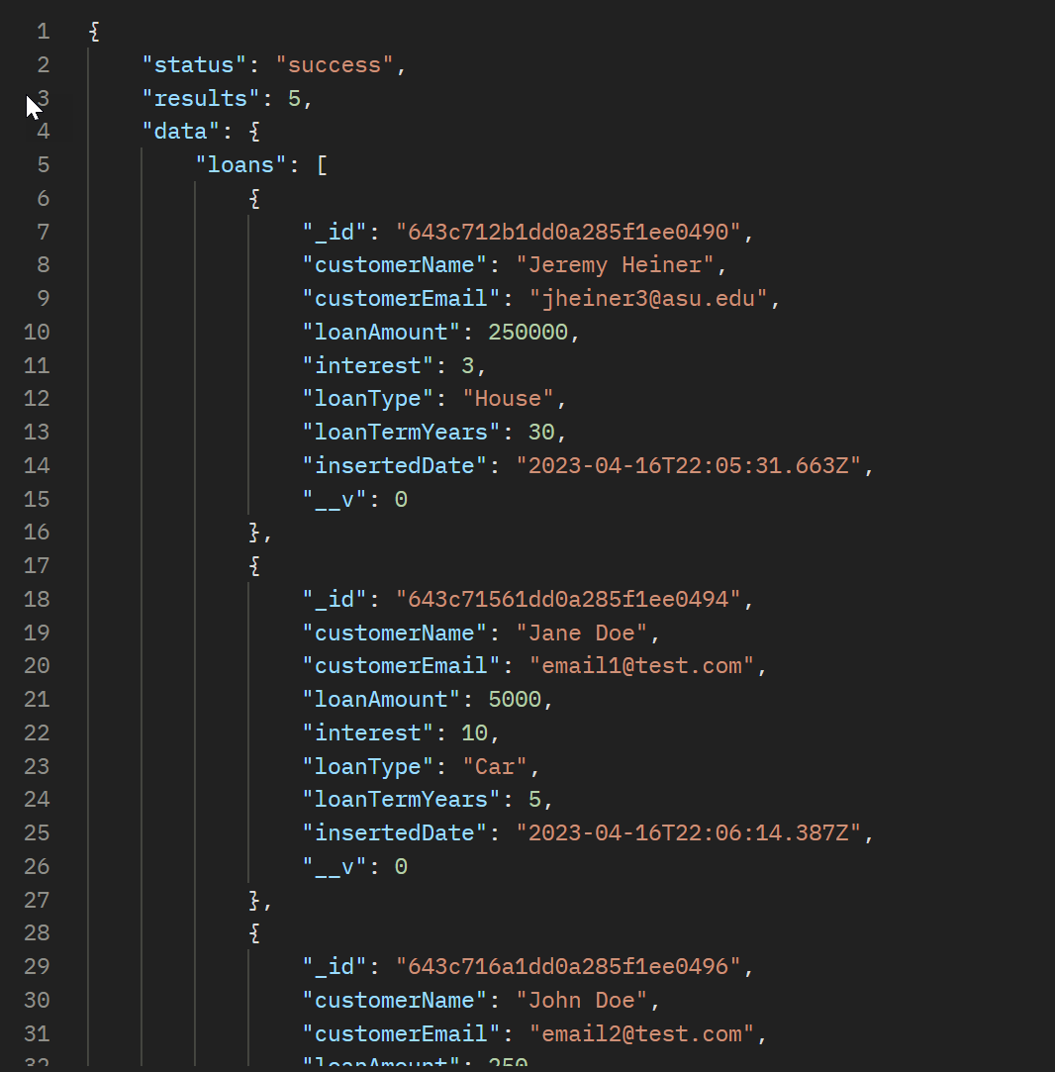

UI GET

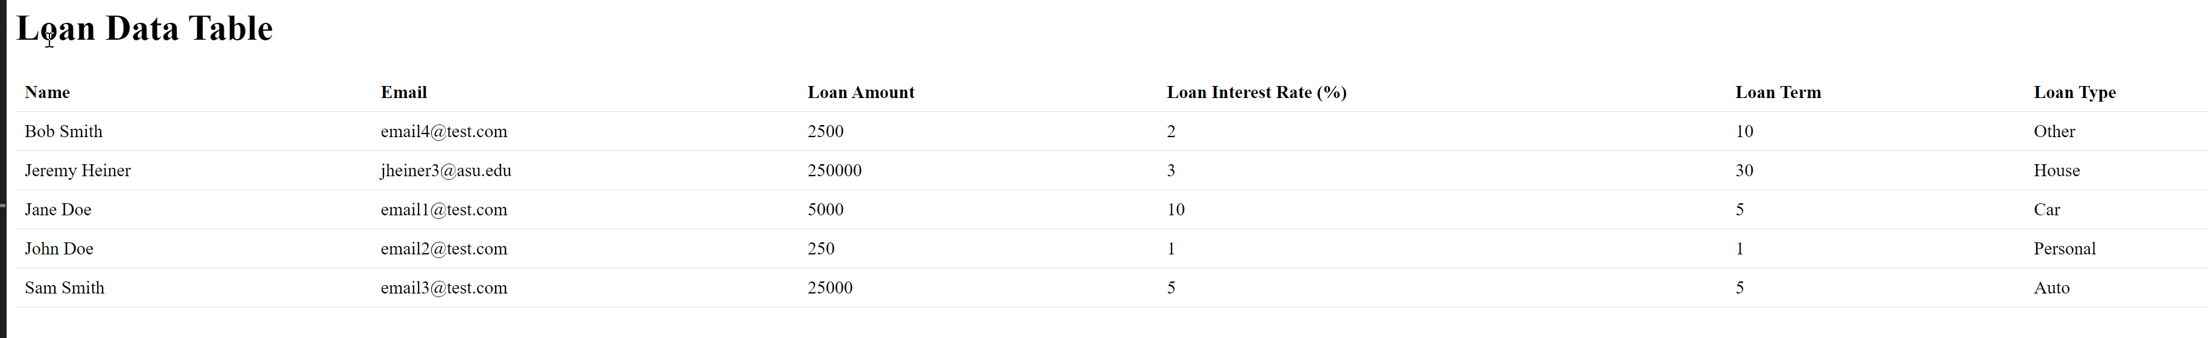

API POST

